Android e-Project

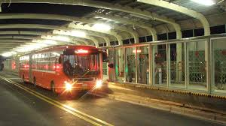

City Bus Management System

**Submitted To**

eProjects@agIsm.com

**Project Instructor**

Sir. Muhammad Salman

**Curriculum Code**

6673

**Group Members**

|  |  |
| --- | --- |
| Student984387 | MUHAMMAD MEHBOOB JILANI |
| Student1000300 | MUHAMMAD IRSHAD |
| Student1000349 | ASAD ALI |
| Student988171 | HAMMAD AHMED |



Project Certification

This is to certify that,

**(**MUHAMMAD MEHBOOB JILANI, Student984387  **)**

**(**MUHAMMAD IRSHAD, Student1000300 **)**

**(Asad Ali**, Student1000349**)**

**(**HAMMAD AHMED, Student988171**)**

Has successfully Designed & Developed

**City Bus Management System**

Submitted by:

**Muhammad Mehboob Jilani**

Date of Issue:

**13th  November 2019**

Authorized Signature: **Sir. Muhammad Salman**

Acknowledgment

I would like to acknowledge all those who have given memorial support and helped in making the eProject success. I wish to express my gratitude to eProject Team at Head Office who guided and helped me. Also, I would like to express my gratitude to all the staff members of my centre for not only providing me the opportunity to work with them on this project, but also for their support and encouragement throughout the process. I also express my sincere gratitude to eProject team from Aptech Head Office and my project guide at the organization for his valuable guidance and support for completion of this project. Finally, I would like to offer many thanks to all my colleagues for their valuable suggestions and constructive feedback.

**THANK YOU……**

Preface

First of all, we would like to thanks ALLAH the almighty, which give us a mind to think and heart to feel creativity. Creation depends on thinking.

Many people contributed to this project, and I would like to thank all of them. I guess I should start with my Teacher Sir. Muhammad Salman of APTECH IIC for her expert advice.

Very special thanks to our entire teachers who gave us valuable teaching and brilliant suggestion and always encourage us to do the best. Indeed class fellows are very important and we would like to thank all of them for their kind appreciation, encouragement and moral support.

We would also like to express our deepest gratitude to our parents whose well wishes enabled us to transform our dream into a reality. Finally my sincere thanks to my teacher Sir. Muhammad Salman all their assistance in making this concept a reality.

Tables Of Contents

**Project Certification 2**

**Problem Definition 4**

**Customer Requirement Specification 5**

**Project Duration 6**

**Task Sheet 7**

**Screen Shots 11**

Introduction to Blood Bank Management System

**Blood Bank Management System.** The Main Objective of this System is to design an Android Application to find out the bus number from one place to another place..

**REQUIREMENT SPECIFICATION**

**Description:** City Bus Management application should work without internet connectivity. This is the major advantage this particular application has a database of its own which makes it independent of internet, and it displays the bus numbers on its own. This makes finding of the bus numbers easy, fast and efficient

* User need to give the details of source and destination.
* Accordingly it will display the details of the bus number which is going in that route.
* It is a time saving application to user.
* User can easily get the information of the bus number of a particular route.
* In this way a user will be free of confusion about the buses.
* It will also be very helpful for those people who are new to the city.

**Purpose:**

This project consists of two parts:

**Users** (mobile application)

**Administrator** (mobile application)

**Users (mobile application):** User should register for using this app. With their name, contact no, emailed, Category like Student etc., after successfully register user can find out the bus number from one place to another place and user get Update related to Bus and about this route if is route is change.

**Administrator(mobile application):**  Admin can Update the database if any bus route change and Add other information related to bus.

**Hardware/ Software Requirements**

**Hardware**

* Android mobile with a minimum version 2.2.
* The processor is not less than 500MHZ.
* RAM is not less than 2048MB.
* SD card with a minimum of 512MB.
* Resolution is not less than 480*800pixs.

**Software**

* Use software as per your requirement
* Windows OS/JAVA/Android SDK/Notepad/SQL/Android 2.2 or Later

Project Duration

**Duration:**

a. Analysis-18 Hrs.

b. Design 11 Hrs.

c. Development 22Hrs

d. Testing 12 Hrs

e. Documentation -20 hrs

Task Sheet

|  |  |  |  |  |  |
| --- | --- | --- | --- | --- | --- |
| **No.** | **Task** | **Actual Start Date** | **Actual Days** | **Team Mate Name** | **Status** |
| 1. | Case Study | 13th November 2019 | 3 | **Arsalan Majeed** | Completed |
| 2. | Graphics Designing | 15th November 2019 | 5 | **Arsalan Majeed** | Completed |
| 3. | User Interface Designing | 21st November 2019 | 6 | **Arsalan Majeeed M.Zain Ul Abdin** | Completed |
| 4. | Backend Programming | 25th November 2019 | 3 | **Arsalan Majeed Shahzaib Shehryar and Muhammad Zain Ul Abdin** | Completed |
| 5. | Application Testing/Publishing | 30th November 2019 | 4 | **Arsalan Majeed Shahzaib Shehryar and Muhammad Zain Ul Abdin** | Completed |
| 6. | Documentation | 5th December 2019 | 5 | **Arsalan Majeed Shahzaib Shehryar and Muhammad Zain Ul Abdin** | Completed |

EntityRelationshipDiagram

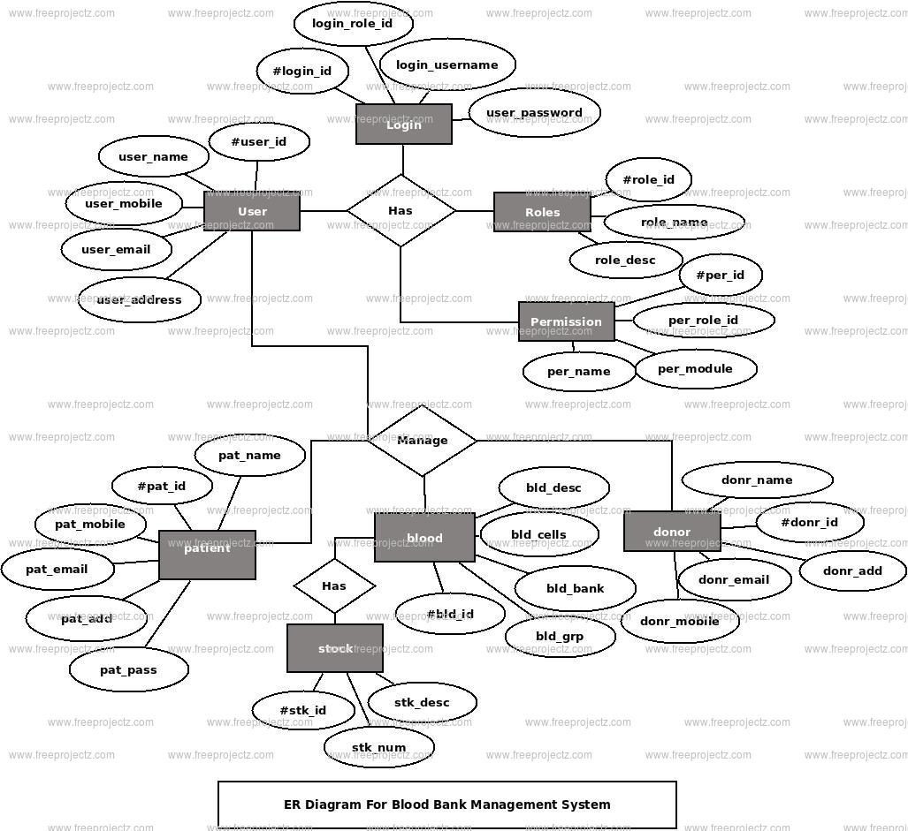

Site Map

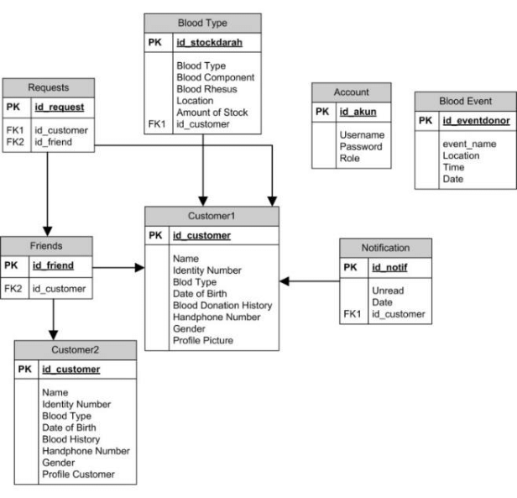

List of Validation

|  |  |
| --- | --- |
| Option | Validation |
| Fields in Form should not be Null | Yes |
| Hyperlinks Have Alternating Text | Yes |
| Search Pages | No |
| Homepage Has Forward Only Link | Yes |
| All app pages have link back to Homepage | Yes |
| Request Quote Form Included | No |
| All Functions Are Compatible with Android | Yes |
| All Functions Are Compatible with IOS | No |

Submission Checklist

|  |  |  |  |
| --- | --- | --- | --- |
| **S.NO** | **LIST OF ITEMS** | **Remarks** | **COMMENTS** |
| 1. | Do All Pages Linked together | **Yes** | Tested |
| 2. | All Hyperlinks working | **Yes** | Tested |
| 3. | Page Colors As Per Common Guidelines | **Yes** | Checked |
| 4. | app screen Compatible | **Yes** | Tested in Chrome |
| 5. | Image Slicing | **Yes** | Created using photoshop |
| 6. | Feedback Form Included | **Yes** | Included |
| 7. | Project Zip File | **Yes** | Created using WinRAR |

Snap Shots

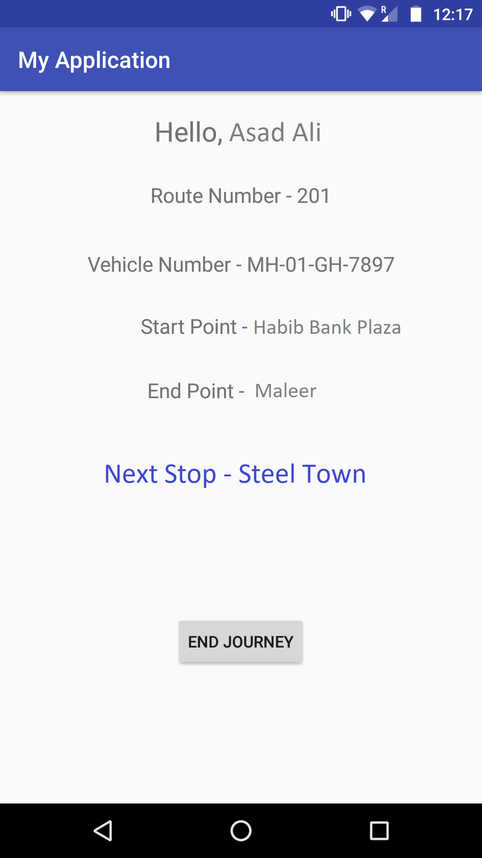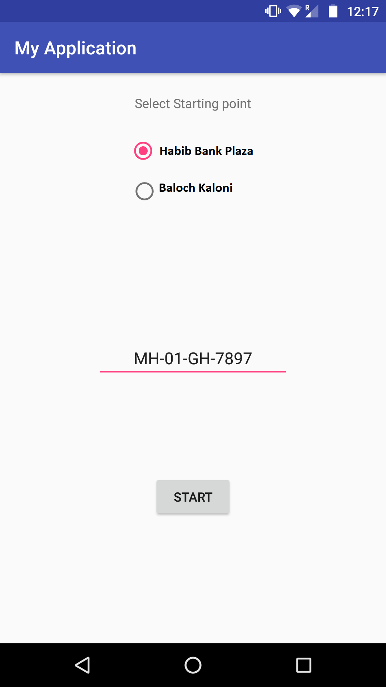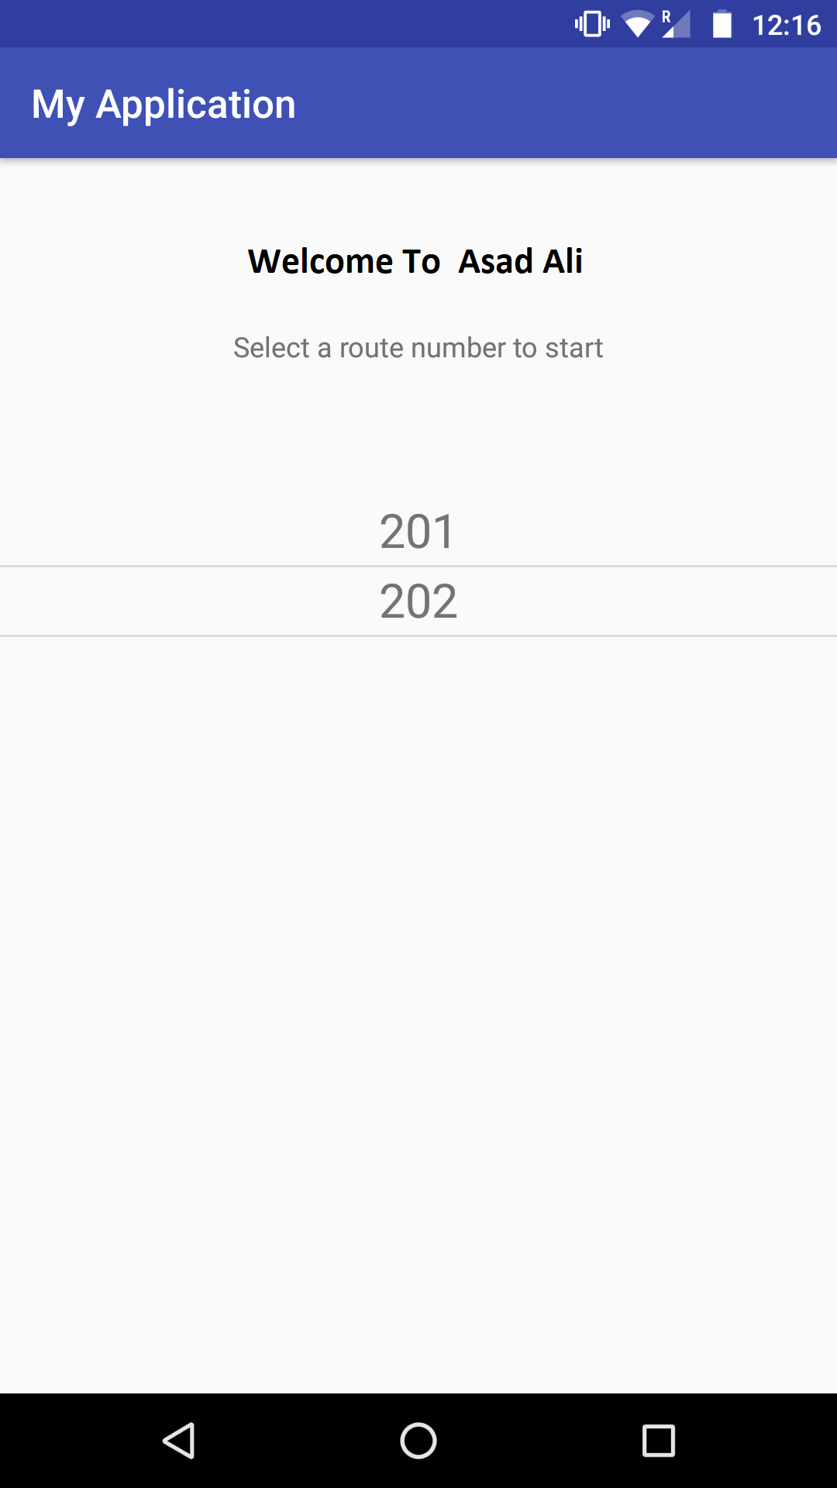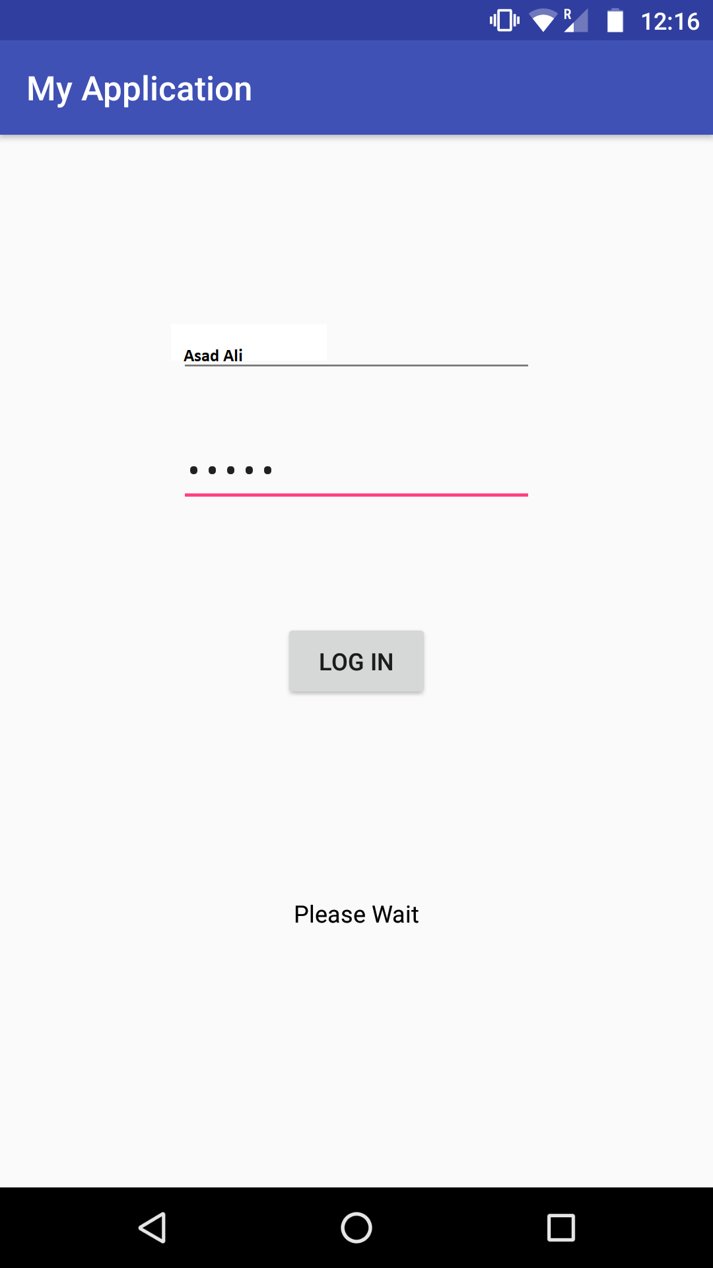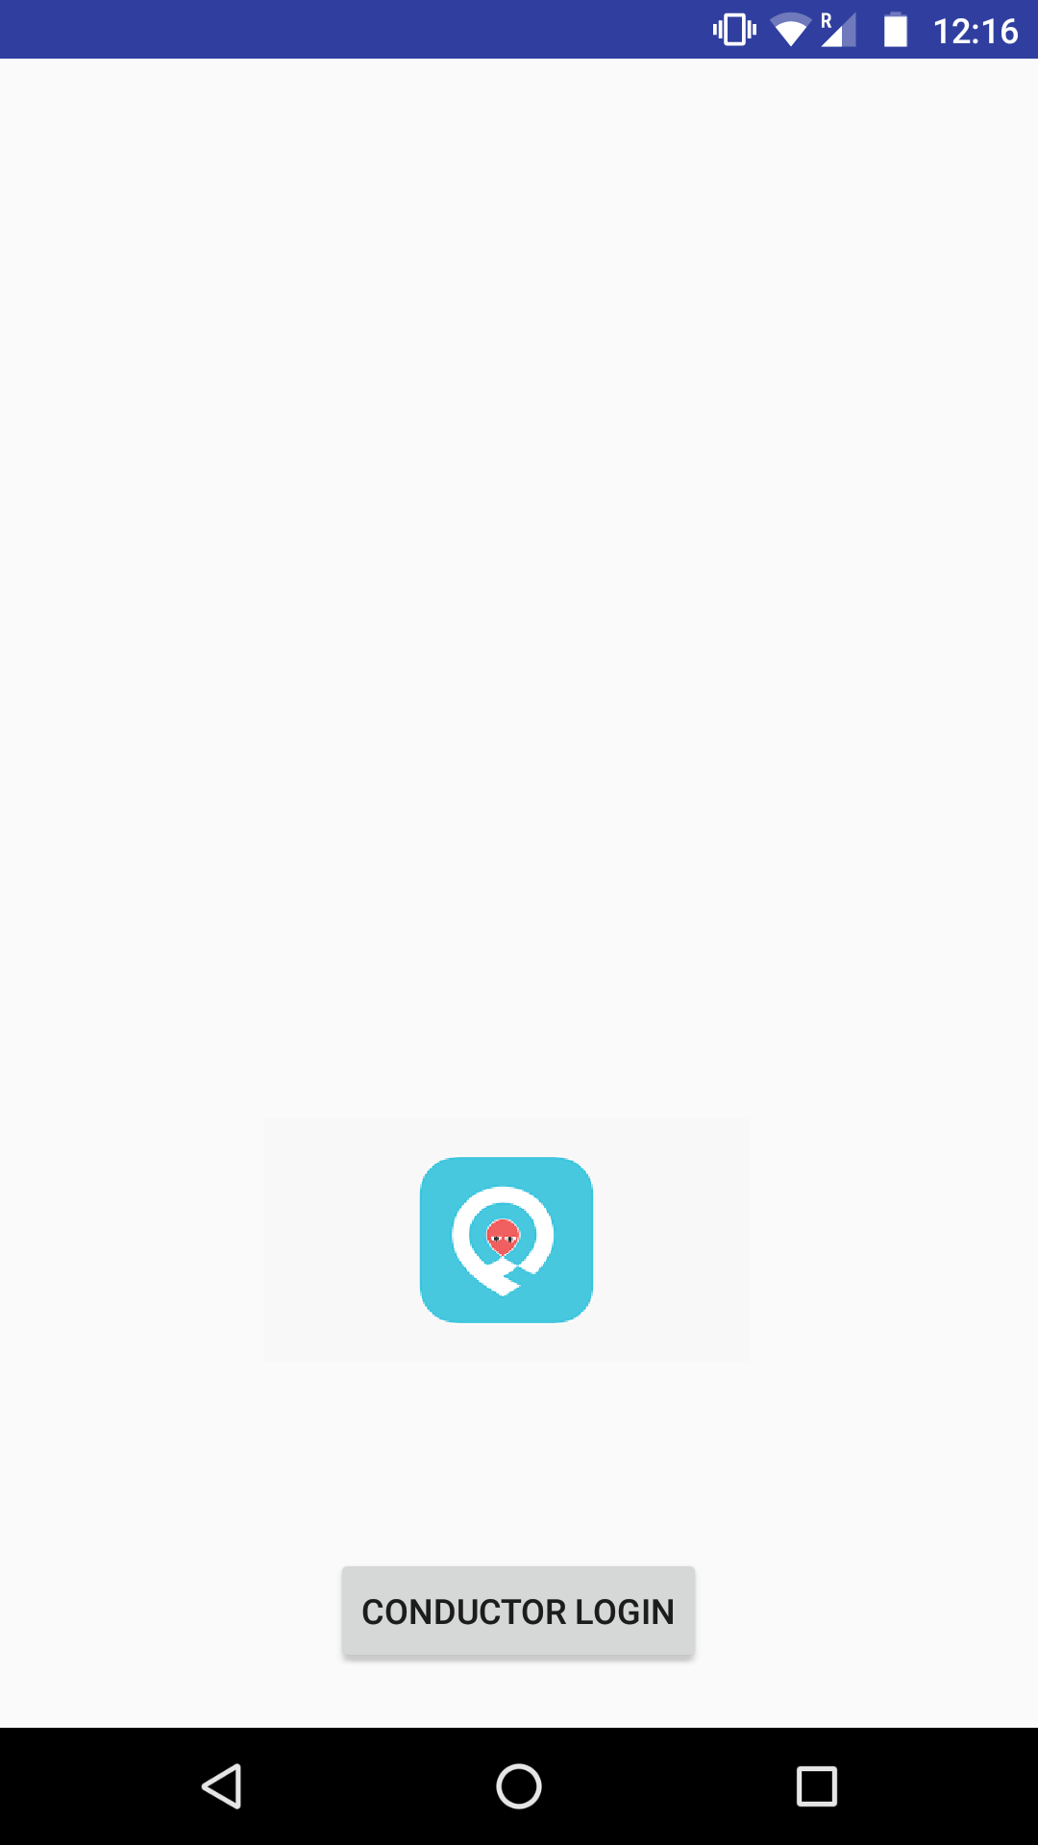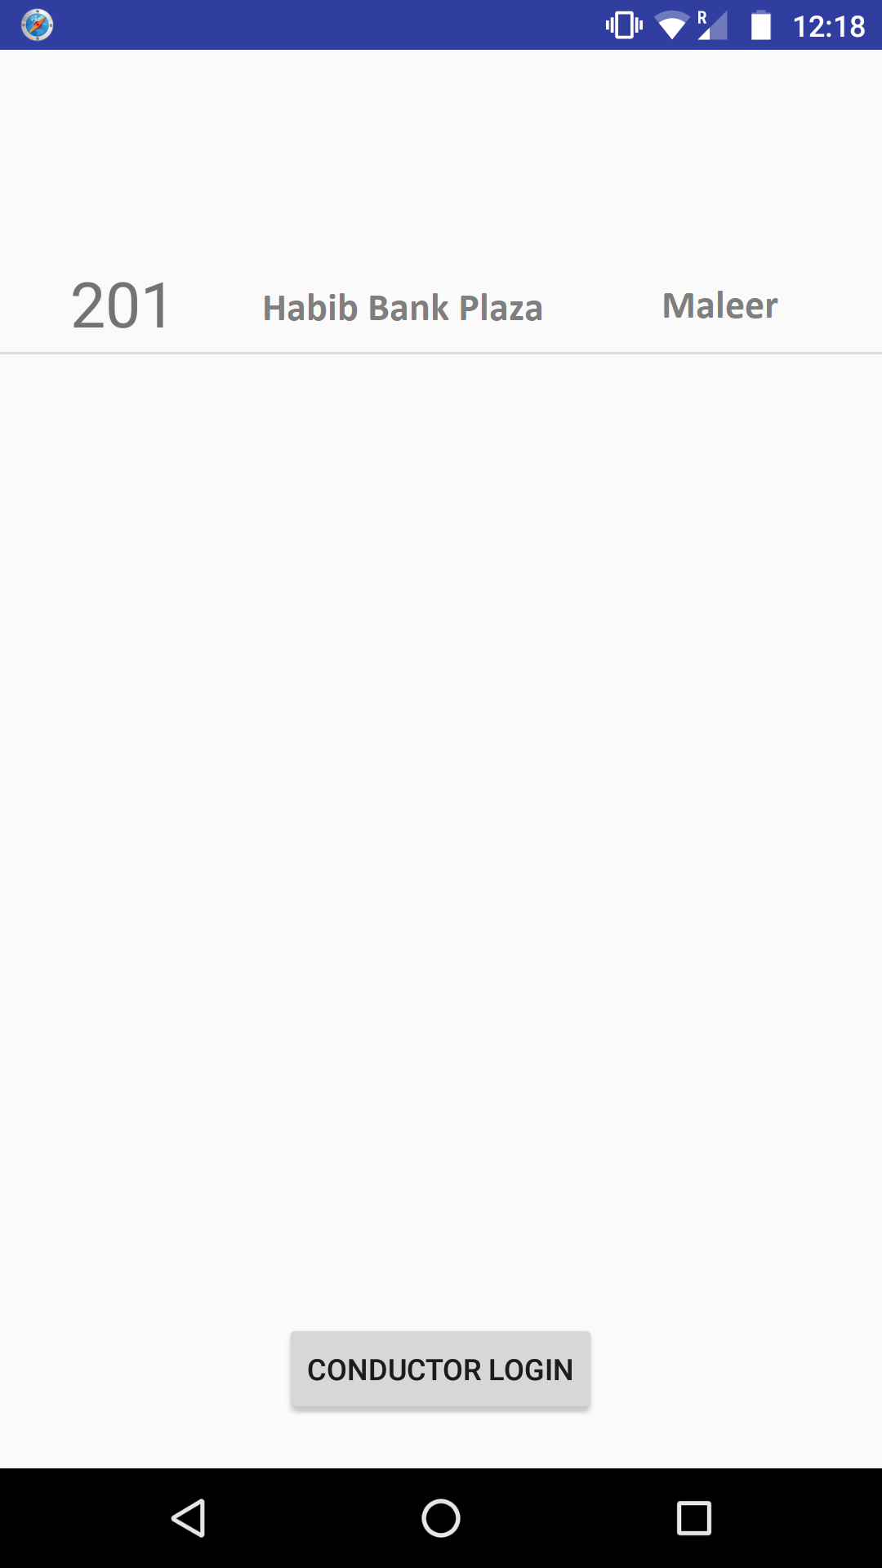

Snap Shots

